## CPU Profiler Tutorial

The CPU Profiler component in CodeXL is used for performance analysis and tuning of applications running on CPU. It is used to identify the various factors affecting the performance of the profiled application or the entire system.

This tutorial provides step-by-step instructions for using CodeXL to analyze the performance of an application program. It consists of the following modules.

**Preparing an Application for CPU Profiling**

**Create a CodeXL Project for CPU Profiling**

**Set the global options for CPU Profiling**

**Set the CPU Profile Session Options**

**Analysis with Time-based Profiling(TBP)**

**Analysis with Event-based Profiling(EBP)**

**Analysis with Instruction Based Sampling(IBS)**

**Analysis with Cache Line Utilization (CLU**)

**Settings for C++ Inline Functions**

**Settings for CPU Profiler to run on Virtual Machine**

**How to use CPU Profiler Control APIs**

### Preparing an Application for CPU Profiling

The CodeXL CPU Profiler uses the debug information generated by the compiler to show the correct function names in various analysis views and to attribute the collected samples to source statements in Source View. Otherwise, the results of the CPU Profiler would be less descriptive, displaying only the assembly code, and the functions would be reported as **NO SYMBOL**.

Generate Debug Information on Windows

When compiling an application in release mode, you can produce the debug information to enable CodeXL to perform an analysis. When using Microsoft Visual C++ to compile the application in release mode, set the following options to ensure that the debug information is generated and saved in a program database file(with a .pdb extension).

To set the compiler option to generate the debug information for a Win32 application in release mode:

1. Right click on the project and select **Properties** menu item.
2. In the **Configuration** list, select **Active(Release)**.
3. In the **Platform** list, select **Active(Win32)**.
4. In the project pane, expand the Configuration Properties folder, then expand the C/C++ folder.
5. Select **General**.
6. In the work pane, select **Debug Information Format**, and from the drop-down list select **Program Database (Zi)** or **Program Database for Edit & Continue (/ZI)**.

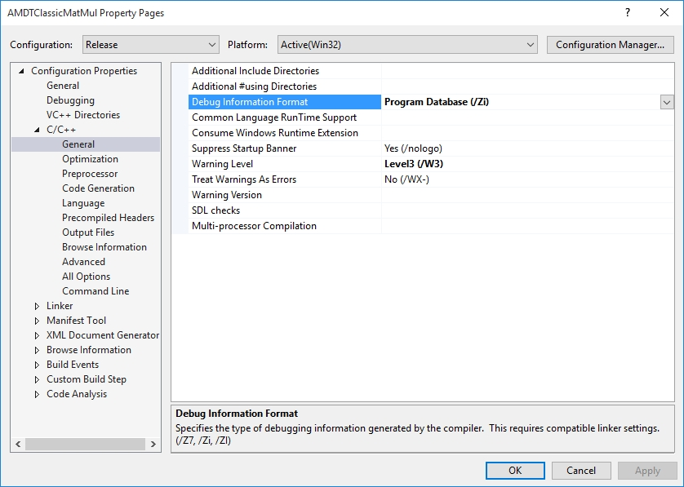

1. In the project pane, expand the Linker folder; then expand the **Debugging** folder.
2. In the **Generate Debug Info** list, select **Yes (/DEBUG)**.

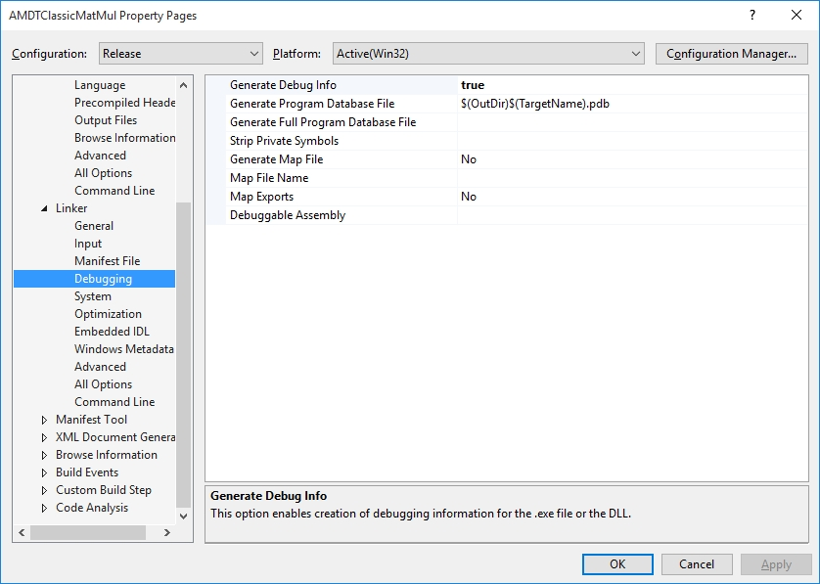

Generate Debug Information on Linux

The application must be compiled with the -g option to enable the compiler to generate debug information. Modify either the Makefile or the respective build scripts accordingly.

### Create a CodeXL Project for CPU Profiling

To start profiling their application, you must create a new CodeXL Project and set the appropriate settings. The following steps explain how to create a new CodeXL Project.

1. Once CodeXL is launched, click on **Create New Project** link in the main pane, or select **File > New Project...**   
   The **Create a new CodeXL Project** dialog box is displayed.
2. Select the **General** tree node on the left pane.
3. In the **Executable Path** box, click **Browse**, and select the application to be profiled.
4. By default, CodeXL uses the name of the application as the project name. To modify the project name, edit the **CodeXL Project Name** box.
5. Edit the other boxes that are required for executing the application to be profiled.

* **Working Directory**
* **Command Line Arguments** (optional)
* **Environment Variables** (optional)
* **Source Files Directories** (optional)

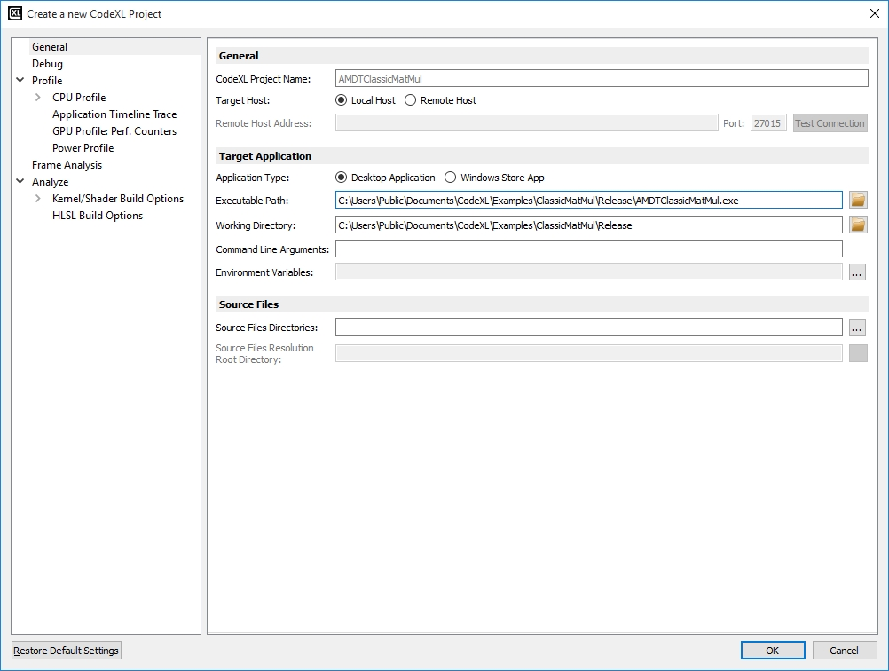

1. Click **OK**.   
   A new CodeXL project is created and displayed in the Session Explorer window.

#### Creating CPU Profiling Project for Windows Store (Metro) Apps

1. Once CodeXL is launched, click on **Create New Project** link in the main pane, or select **File > New Project...**   
   The **Create a new CodeXL Project** dialog box is displayed as shown in the previous screenshot.
2. Select the **General** tree node on the left pane.
3. Select “**Application Type**” as “**Windows Store App**”. Please note that Store Apps are only available on Windows 8.x or later versions.
4. In the **Executable Path** box, click **Browse**. The **Select Windows Store app** dialog will be displayed. Select the Store App to be profiled. Select **OK**.

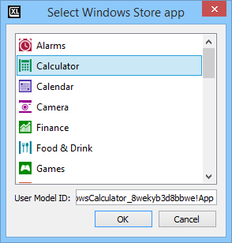

1. Configure other settings as described in the previous section item 4, 5.
2. Click **OK**.

A new CodeXL project for Windows Store App is created and displayed in the Session Explorer window.

### Set the global options for CPU Profiling

Specify the global CPU profile settings by modifying the **CodeXL Options** dialog box. The following steps explain how to do this.

1. Select the profile mode by selecting **Profile > Profile Mode - CPU: Time-based Sampling** or by clicking the Profile icon 
2. Select **Tools > Options...** menu item.  
   The **CodeXL Options** dialog box is displayed.
3. Select the **General** tab, as shown in the following screenshot.

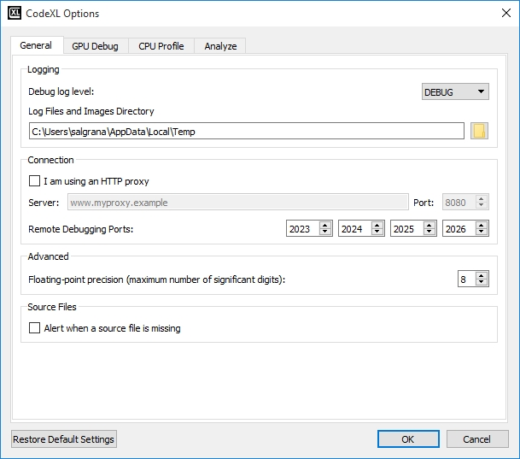

1. Select **Alert when a source file is missing** check box if you want CodeXL to pop up an alert message dialog box if source files are missing.
2. Select the **CPU Profile** tab, as shown in the screenshot in the below sub-section ‘Setting Symbol Server Path’.

#### Setting Symbol Server Path

1. If any additional debug symbol paths are to be specified to find the required .pdb files, select the **Additional debug symbol paths** check box, **browse,** and select the folder in which PDB files are kept.
2. Select **Symbol Server Directories** to enable the support of Microsoft symbol server technology. Set the download directory and select Microsoft symbol server link. Additional symbol server paths can be added to this list. (See the help file for a detailed description of the available options.)

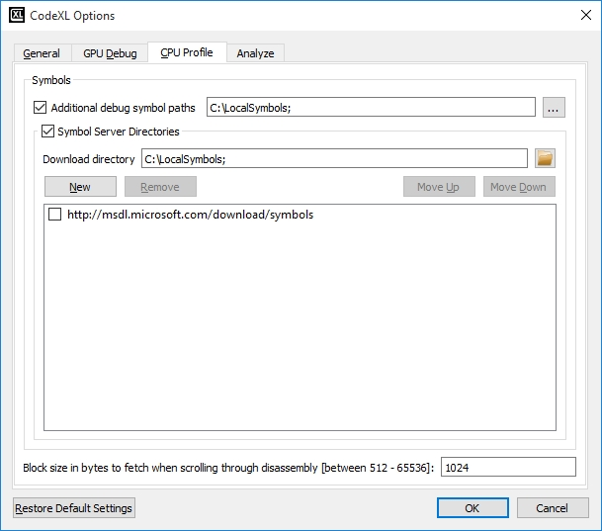

1. Select the block size for disassembly fetch while navigating through disassembly code. The default size of 1024 is usually sufficient.

### Set the General Profile Session Options

1. Click the **Profile > Profile Settings** menu item.
2. Click the **Profile** treenode in the left pane.
3. Select one of the CPU profile types in the profile type combo box. The corresponding description will appear.
4. Select the profile scope:

* **Single Application Profile:** when this option is selected, CodeXL will launch the profiled application (classic.exe in this case), and will collect profile data only from this process.
* **System-Wide Profile:** when this option is selected, CodeXL will not launch the profiled application, and will collect profile data from all the currently running processes.
* **System-Wide Profile with focus on application:** when this option is selected, CodeXL will launch the profiled application (classic.exe). It will collect profiled events data both from classic.exe and other running processes on the machine. For classic.exe, CodeXL will also collect call stack information.

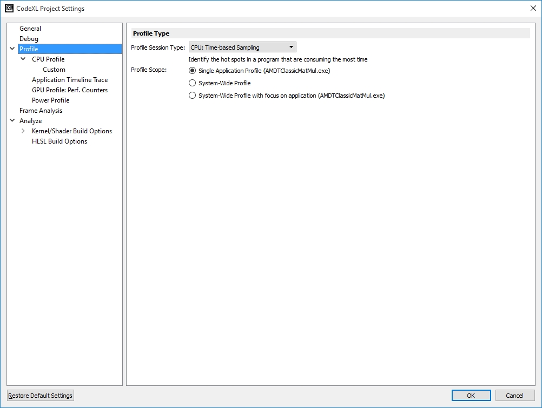

### Set the CPU Profile Session Options

The CPU Profile view is used to control the profile data collection options. The selected settings persist and apply to future profile data collection sessions that are started within a project; they persist until the profile settings are modified.

1. Click the **Profile > Profile Settings** menu item.
2. Click the **Profile** treenode in the left pane. The **CPU Profile** settings page is displayed (see the following screenshot).
3. Select **Collect** **call stack details** to enable the collection of call stack data to analyze caller-called relationships and call frequency.

**Note:** The collection of call stack is not supported for Java or CLR based applications. For those applications, this checkbox would be unchecked and disabled.

* Set the value for **Collect for code executed in** drop box, to apply call stacks collection only to code sampled in User space, Kernel space or both (User space and Kernel space).
* Set the value for **Collect Call Stack every** spin box, to specify how often a CSS sample is taken. If the selected value is N for example, then a CSS sample is taken every N regular samples. By default it is set to 1.
* Set the value for **Call Stack Collection Depth**. Use Maximal for high accuracy, and Minimal for lower performance overhead.

**Note:** This option is set separately for Time-Based Sampling and other CPU Profiling session types.

* Check the **Reproduce missing call stack info** check box, to perform additional analysis to overcome frame-pointer omission (FPO) in 32-bit apps and lack of unwind info in 64-bit. The profiler will store additional data during the profile session and require more time during post-session processing.

**Note:** This option is set separately for Time-Based Sampling and other CPU Profiling session types.

1. In the **Data Collection Schedule** section:

* Select **Throughout entire duration** if you want the data to be collected throughout the entire execution of the profile session.
* Select **Start profile with data collection paused** if you want to start the application and then decide when data collection should be started.
* Select **Scheduled:** if you want to set the data collection start after and end after values. Once this option is checked, set the values for the start / end timing of the data collection.

1. Select / Unselect cores in the cores tree under **Profile Hardware Scope**, when you want to limit the execution of the program to the selected cores in a multicore system.

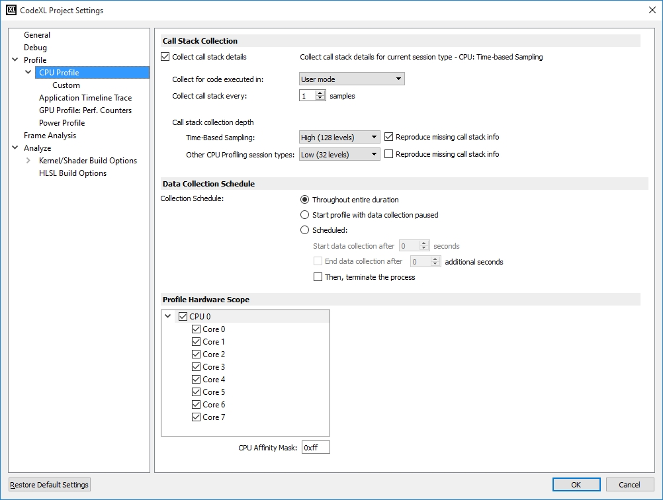

### Analysis with Time-based Profiling (TBP)

**Time-based profiling (TBP)** identifies the hot spots in a program that are consuming the most time. Hot spots are good candidates for further investigation and optimization.

**Collecting TBP profile Data**

**Changing the TBP profile collection options**

**Analyzing the TBP profile data**

#### Collecting TBP profile Data

To collect the TBP data, do the following.

1. Create a new CodeXL Project.
2. In the toolbar, select Time-based profile in the profile configuration list, as shown in the following screenshot.

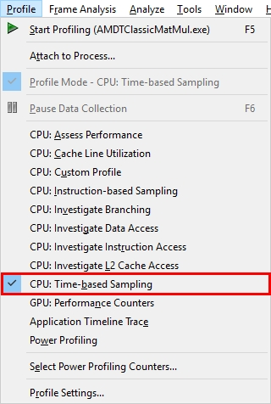

1. Set the profile session options as explained in **Set the CPU Profile Session settings**.
2. Click the Start  button in the toolbar or select **Profile > Start Profiling,** as shown below.

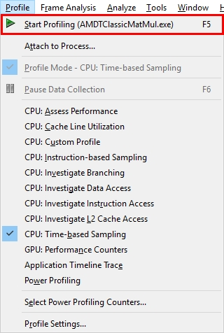

CodeXL begins data collection and launches the specified application program. The start icon is disabled until profiling is in progress. The console window is open, and the launched application is running in the console window. The status bar shows the profile duration while profiling is running; this is the percentage completion of data translation during data translation phase.

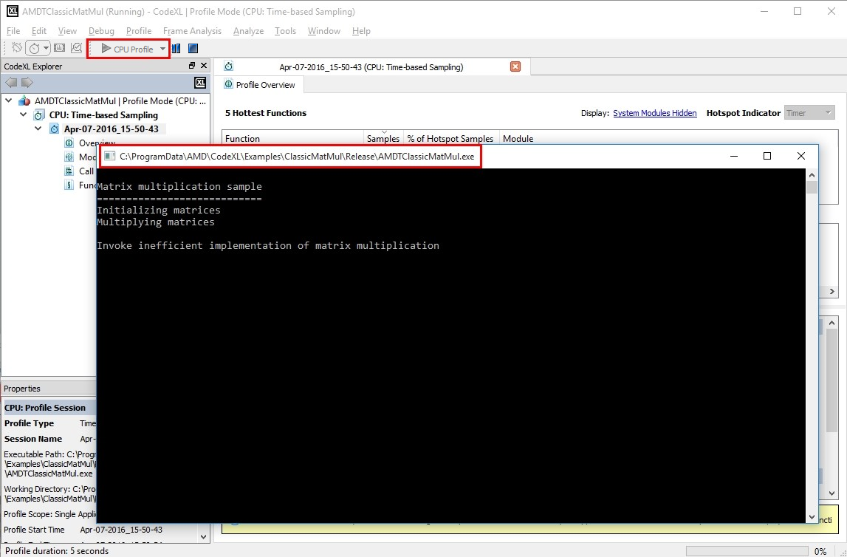

#### Changing the TBP profile collection options

CodeXL lets you modify the default profile collection settings. To do this:

1. Set the profile session options as explained in **Set the CPU Profile Session settings**.
2. By default, the sampling interval for TBP is 1 millisecond. To modify the sampling interval, click **Profile > Profile Settings** and click on the **CPU Profile >** **Custom** node in the left pane tree in the **Edit CodeXL Project Settings** dialog box. The **Custom CPU Profile Monitored Events** page will be displayed.
3. Click the **Interval** field and set the required sampling interval.
4. Click the **OK** button to save the modified profile settings.

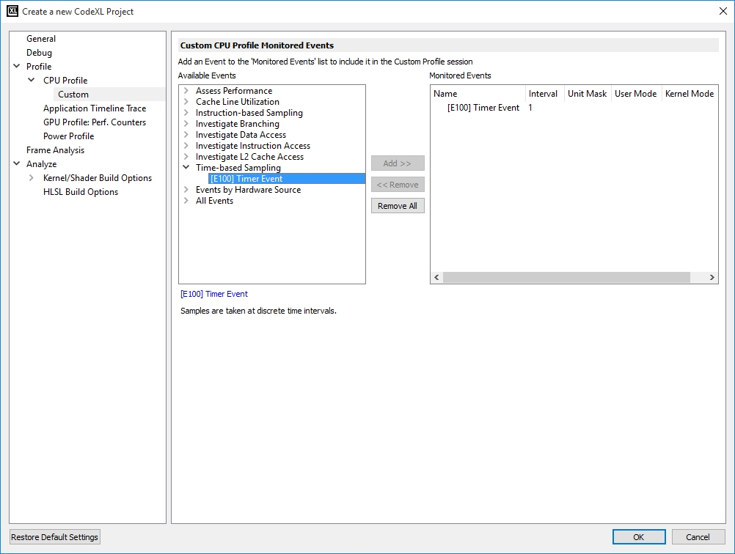

#### Analyzing the TBP profile data

This page explains how to analyze and navigate to the various profile views provided by the CodeXL CPU Profiler. It consists of the following modules.

**Overview page**

**Modules view**

**Functions view**

**Call Graph view**

**Source Code view**

##### Overview page

When data collection is complete, CodeXL processes the data and displays the results.

Initially the **Profile Overview** is displayed with the following profile data.

* **5 Hottest Functions** table
* **5 Hottest Modules** table
* **Execution** section
* **Profile Details** section

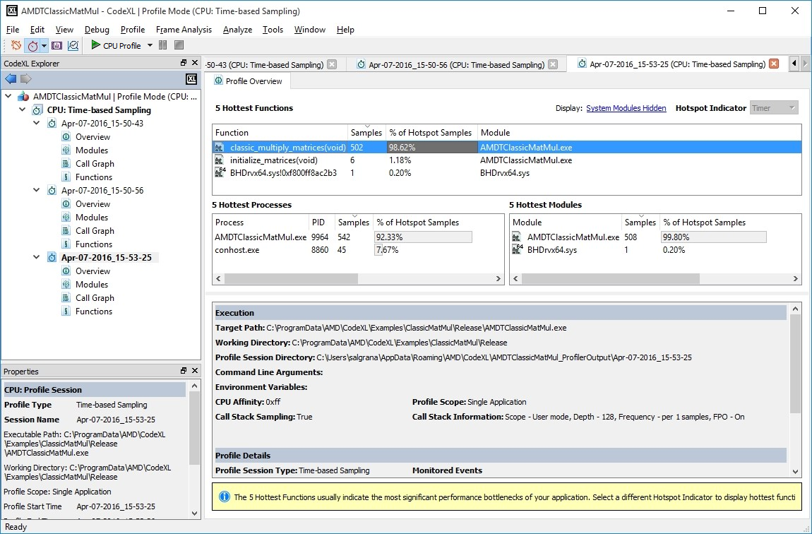

From the overview page you can navigate to various pages to analyze the profile data.

##### Modules view

1. To navigate to Modules view, do one of the following:

* In CodeXL Explorer pane, double-click on **Modules** node in the profile session tree entry created for this profile run.   
  The **Modules** view is displayed.
* In **Overview** page, right-click on **5 Hottest Modules** table entry, and select **Display in Modules View**.   
  The **Modules** view is displayed.

1. Click on the **Display: All Data, All Modules** link to set the Display Settings.   
   The **Display Settings** dialog box is displayed to let you set the various display settings.

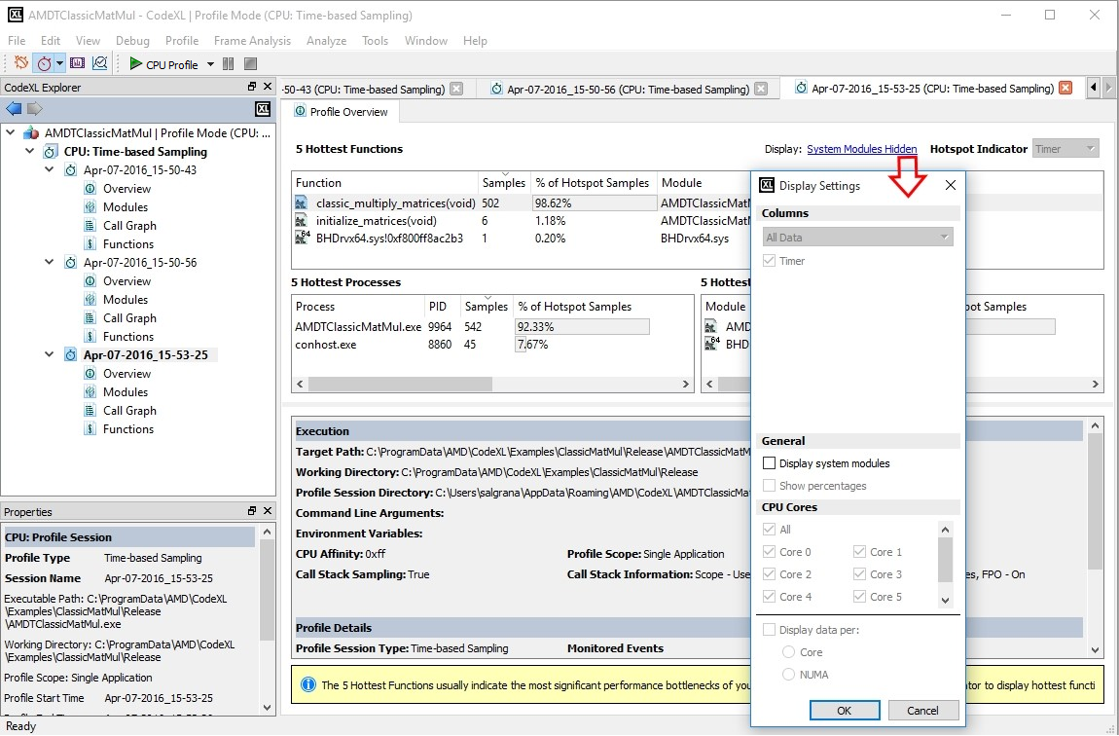

1. Click **OK** button to save the Display filter settings.

##### Functions view

1. To navigate to the Functions view, do one of the following.

* In CodeXL Explorer pane, double-click on the **Functions** node in the profile session tree entry created for this profile run. The **Functions** view is displayed with function entries from all the profiled processes and the load modules.
* In **Overview** page, right-click on the **5 Hottest Modules** table entry, and select **Display in Functions View**.   
  The **Functions** view is displayed with function entries from the selected load module.
* In **Overview** page, right-click on the **5 Hottest Functions** table entry, and select **Display in Functions View**.   
  The **Functions** view is displayed with function entries from all the profiled processes and the load modules.
* In **Modules** view, select a Process from the **Processes** table, and select **Display in Functions View**.   
  This displays the functions from the selected process and all its load modules.
* In **Modules** view, select a Module from the **Modules filtered by selected processes** table, and select **Display in Functions View**.   
  This displays the functions from the selected load module.

1. Click on **Display: All Data, All Modules** link to set the display settings.   
   The **Display Settings** dialog box is displayed to let you set the various display settings.
2. Click **OK** button to save the Display filter settings.
3. Click on **modules shown, modules hidden** link to set the module filter settings to be used in the Functions view.   
   The **CodeXL Modules Filter** dialog box is displayed to let you set the module filter settings.

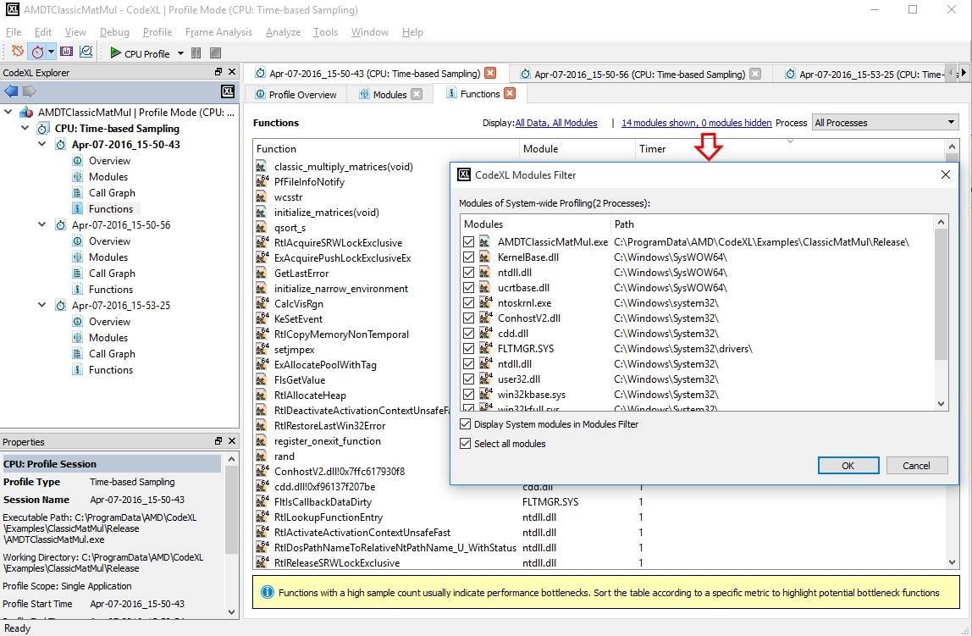

1. Click the **OK** button to save the Modules filter settings.

##### Call Graph view

1. To navigate to Call Graph view, do any of the following:

* In CodeXL Explorer pane, double-click on **Call Graph** node in the profile session tree entry created for this profile run.   
  The **Call Graph** view is displayed with Callstack samples collected for the profiled application.
* In **Overview** page, right-click on the **5 Hottest Functions** table entry, and select **Display in Call Graph View**.   
  The **Functions** view is displayed with Callstack samples collected for the profiled application.
* In **Functions** view, select a function from the **Functions** table, and select **Display in Call Graph View**   
  This displays the Call Graph constructed from the callstack samples collected from the profiled application.

1. Click on the **Display: All Modules** link to enable **Display system modules**.   
   This displays the callstack samples collected from the system modules.
2. Click the **OK** button to save the Display filter settings.
3. Click on the **Process** combo box to select the process for which you want to view the Call Graph.

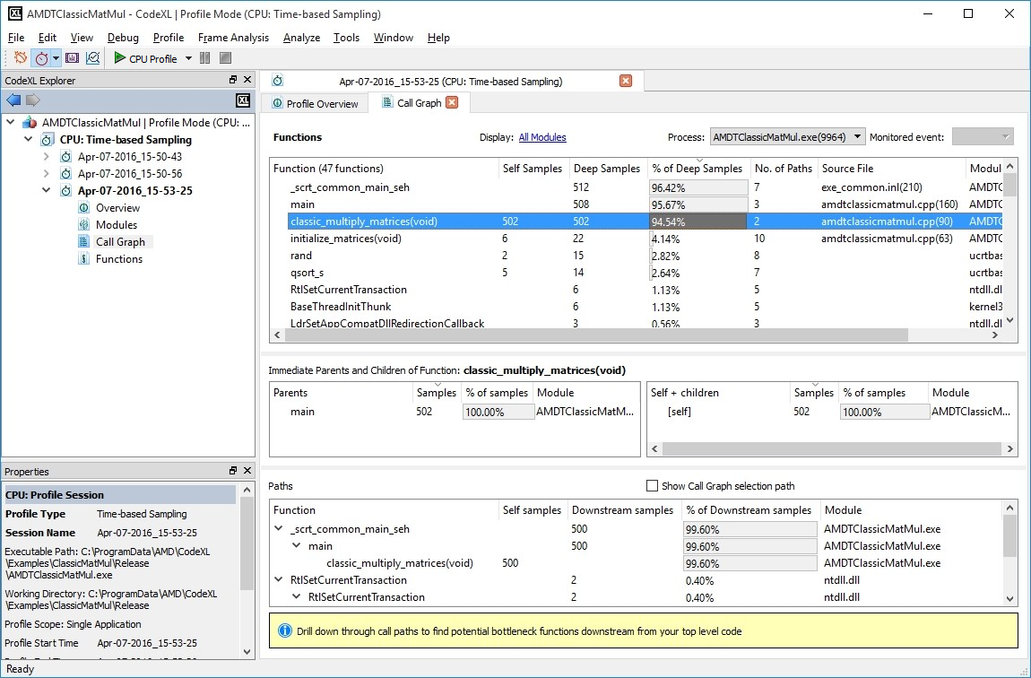

##### Source Code view

1. To navigate to Call Graph view, do any of the following:

* In the **Overview** page, right-click on the **5 Hottest Functions** table entry, and select **Open Source Code**.   
  This displays the **Source Code** view for the selected function.
* In the **Functions** view, select a function from the **Functions** table, right-click and select **Open Source Code** from the context menu.   
  This displays the **Source Code** view for the selected function.
* In **Call Graph** view, select a function from the **Functions** table, right-click and select **Open Source Code** from the context menu.   
  This displays the **Source Code** view for the selected function.

1. To view the sources for the some other function, click on the **Function** combo-box, and select the function for which you want to view the source code.

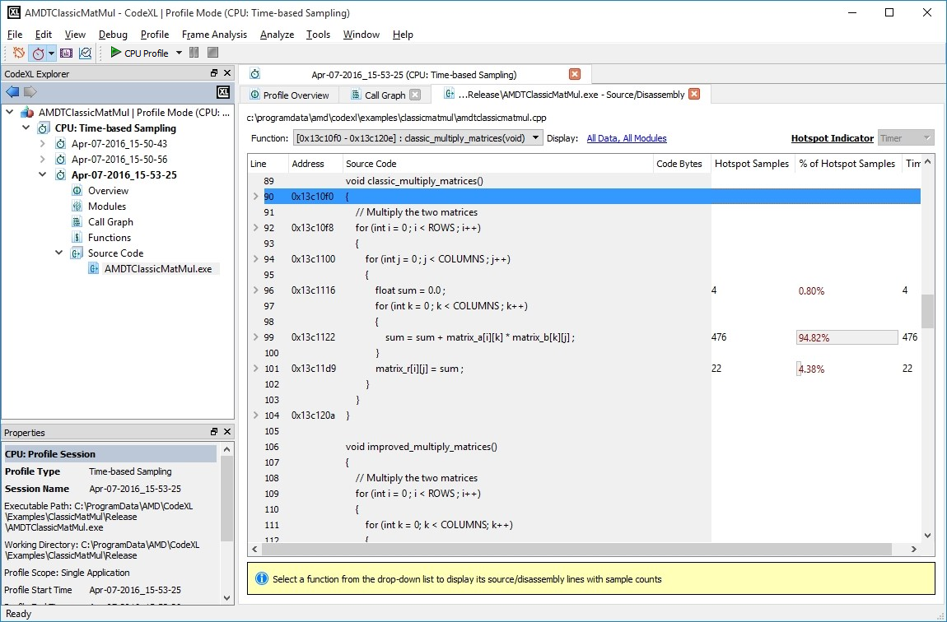

### Analysis with Event-based Profiling (EBP)

**Event-based profiling (EBP)** uses the hardware performance event counters to measure the number of specific kinds of events that occur during execution. Examples of events include processor clock cycles, retired instructions, data cache accesses, and data cache misses. The specific events to be measured are determined by the profile configuration that is used to set up data collection. This section comprises the following modules.

**Collecting EBP profile data**

**Changing the EBP profile collection options**

**Analyzing the EBP profile data**

#### Collecting EBP profile data

To collect the EBP data:

1. **Create a new CodeXL Project**
2. In the toolbar, select **CPU: Assess Performance** from the profile configuration list.   
   This is a predefined Event-based profile configuration provided by CodeXL.

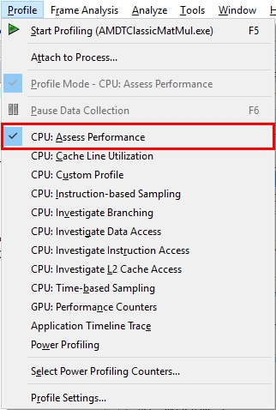

1. Set the profile session options as explained in **Set the CPU Profile Session settings**.
2. Click the Start  icon in the toolbar, or select **Profile > Start Profiling,** as shown below.

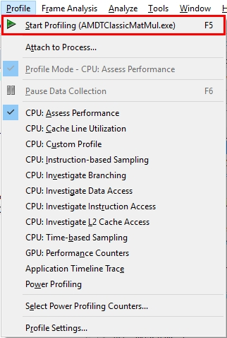

CodeXL begins data collection and launches the specified application program. The start icon has been clicked and is disabled while profiling is in progress. The console window is open, and the launched application is running in the console window. The status bar displays the profile duration while profiling is running; this is a percentage of completion of data translation during data translation phase.

#### Changing the EBP profile collection options

CodeXL lets you modify the default profile collection settings. To do this:

1. Set the profile session options as explained in **Set the CPU Profile Session settings**.
2. By default, the sampling interval for TBP is 1 millisecond. To modify the sampling interval, click **Profile > Profile Settings** and click the **CPU Profile >** **Custom** node in the left pane tree in the **Edit CodeXL Project Settings** dialog box. The **Custom CPU Profile Monitored Events** page will be displayed.
3. Click the **Interval** field and set the required sampling interval.
4. Click the **OK** button to save the modified profile settings.

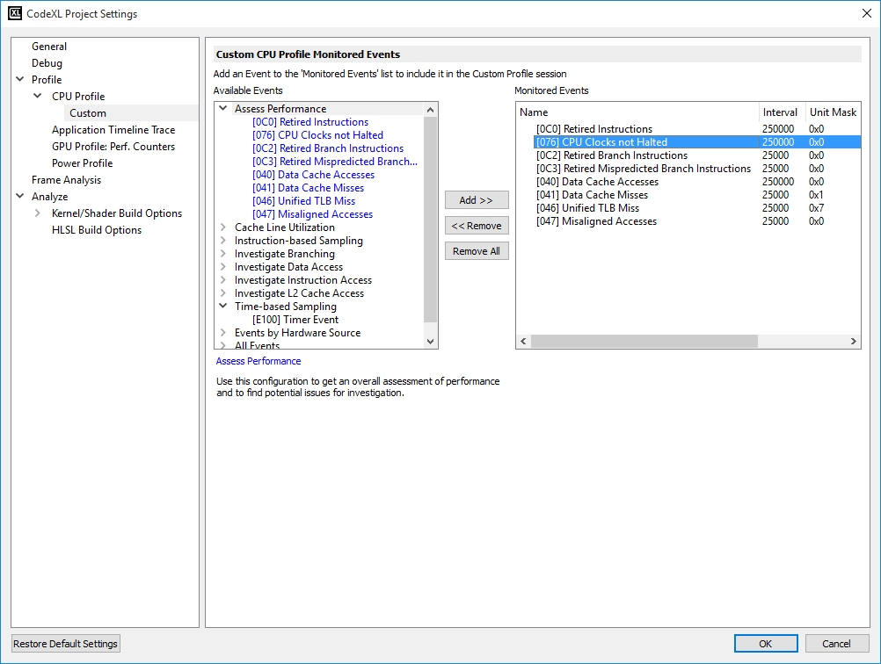

#### Analyzing the EBP profile data

This page explains how to analyze and navigate to the various profile views provided by the CodeXL CPU Profiler. Its modules are:

**Overview page**

**Modules view**

**Functions view**

**Call Graph view**

**Source Code view**

##### Overview page

When data collection is complete, CodeXL processes the data and displays the results.

Initially, the **Profile Overview** is displayed with the following profile data:

* **5 Hottest Functions** table
* **5 Hottest Modules** table
* **Execution** section
* **Profile Details** section

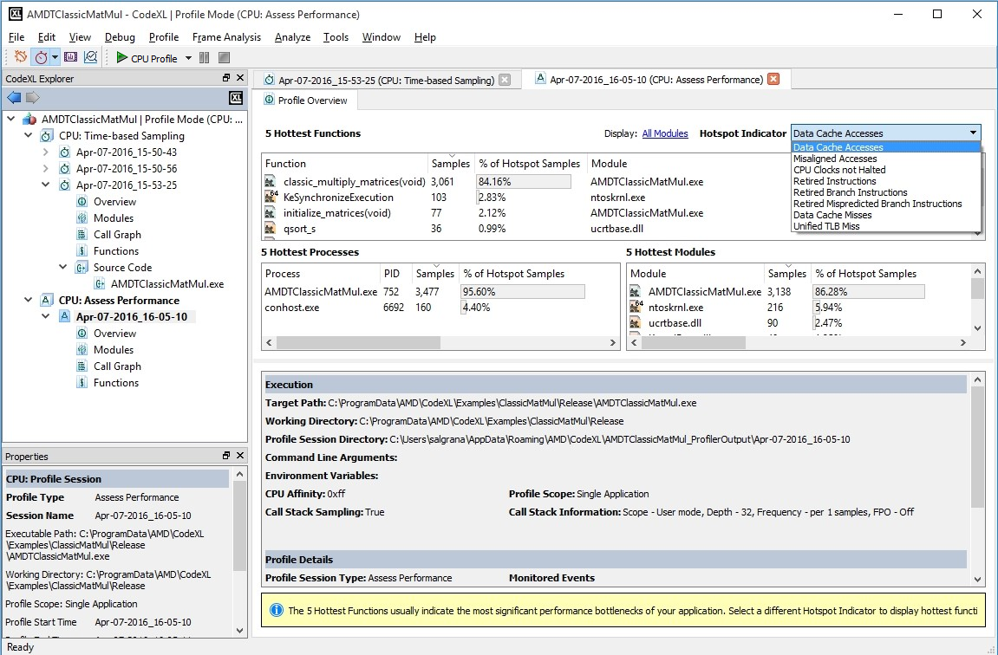

From the overview page, you can naviagte to various pages to analyze the profile data.

##### Modules view

1. To navigate to the Modules view, do one of the following.

* In CodeXL Explorer pane, double-click on the **Modules** node in the profile session tree entry created for this profile run.   
  The **Modules** view is displayed.
* In **Overview** page, right-click on the **5 Hottest Modules** table entry, and select **Display in Modules View**.   
  The **Modules** view is displayed.

1. Click on the **Display: All Data, All Modules** link to set the Display Settings.   
   The **Display Settings** dialog box is displayed to let you set the various display settings.

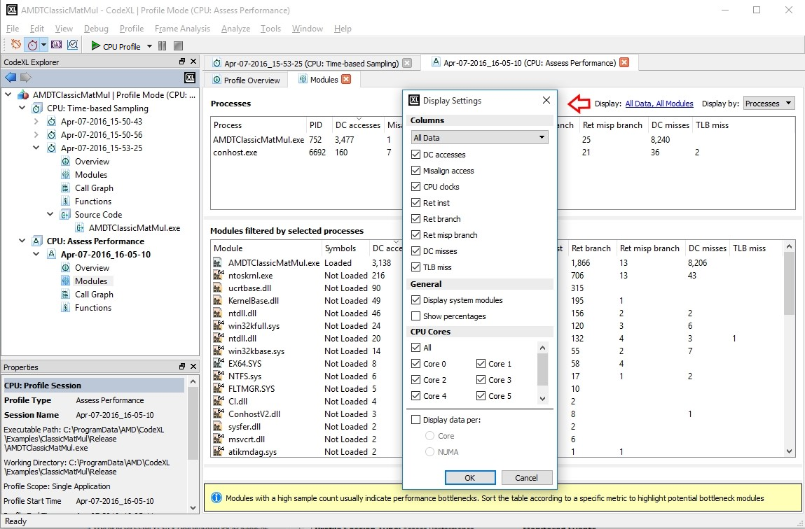

1. Click **OK** button to save the Display filter settings.

##### Functions view

1. To navigate to Functions view, do one of the following:

* In CodeXL Explorer pane, double-click on **Functions** node in the profile session tree entry created for this profile run.   
  The **Functions** view is displayed with function entries from all the profiled processes and the load modules.
* In the **Overview** page, right-click on the **5 Hottest Modules** table entry, and select **Display in Functions View**.   
  The **Functions** view is displayed with function entries from the selected load module.
* In the **Overview** page, right-click on the **5 Hottest Functions** table entry, and select **Display in Functions View**.   
  The **Functions** view is displayed with function entries from all the profiled processes and the load modules.
* In the **Modules** view, select a Process from the **Processes** table, and select **Display in Functions View**.   
  This displays the functions from the selected process and all its load modules.
* In the **Modules** view, select a Module from the **Modules filtered by selected processes** table, and select **Display in Functions View**.   
  This displays the functions from the selected load module.

1. Click on the **Display: All Data, All Modules** link to set the display settings.   
   The **Display Settings** dialog box is displayed to let you set the various display settings.
2. Click **OK** button to save the Display filter settings.
3. Click on the **modules shown, modules hidden** link to set the module filter settings to be used in the Functions view.   
   The **CodeXL Modules Filter** dialog box is displayed to let you set the module filter settings.

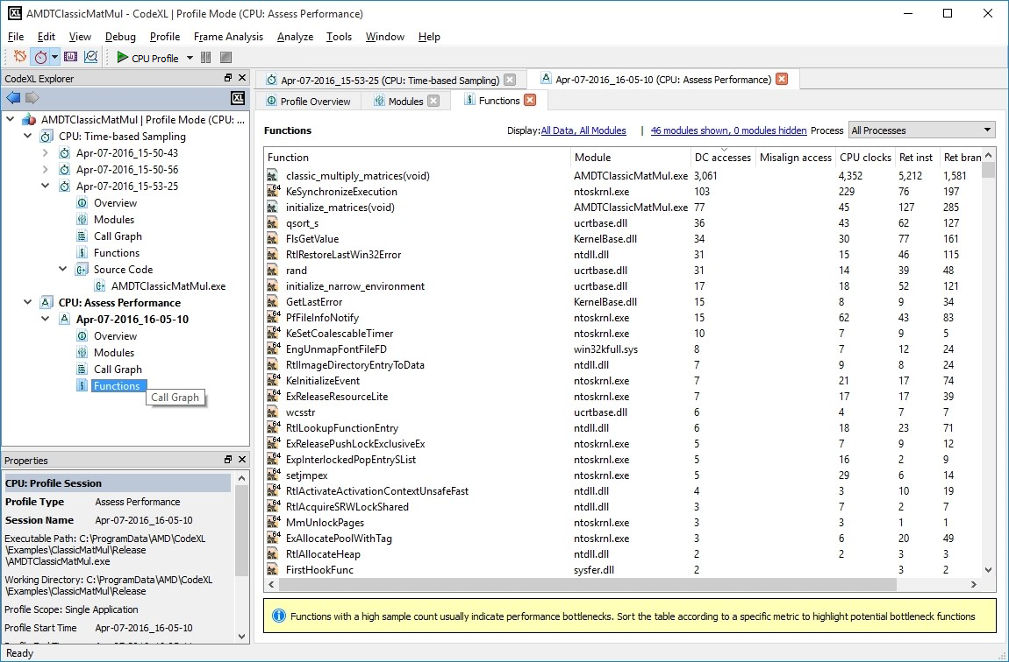

1. Click **OK** button to save the Modules filter settings.

##### Call Graph view

1. To navigate to Call Graph view, do one of the following:

* In the CodeXL Explorer pane, double-click on **Call Graph** node in the profile session tree entry created for this profile run.   
  The **Call Graph** view is displayed with Callstack samples collected for the profiled application.
* In the **Overview** page, right-click on the **5 Hottest Functions** table entry, and select **Display in Call Graph View**. The **Functions** view is displayed with Callstack samples collected for the profiled application.
* In **Functions** view, select a function from the **Functions** table, and select **Display in Call Graph View**   
  This displays the Call Graph constructed from the callstack samples collected from the profiled application.

1. Click on the **Display: All Modules** link to enable **Display system modules**.   
   This displays the callstack samples collected from the system modules.
2. Click the **OK** button to save the Display filter settings.
3. Click on the **Process** combo box to select the process for which you want to view the Call Graph.

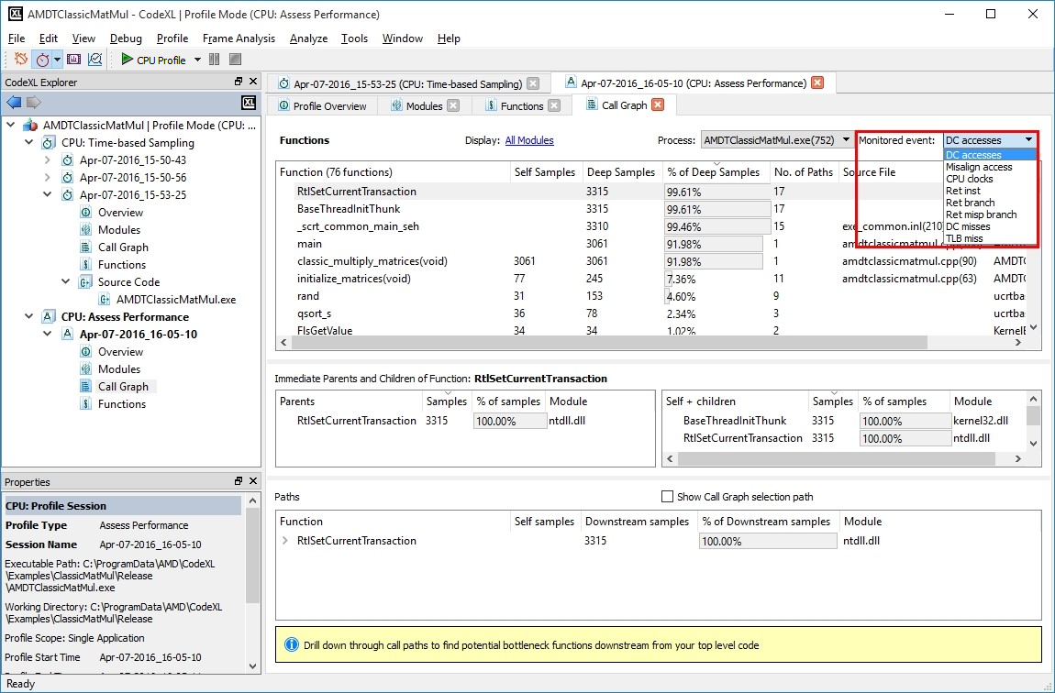

##### Source Code view

1. To navigate to Call Graph view, do one of the following:

* In the **Overview** page, right-click on the **5 Hottest Functions** table entry, and select **Open Source Code**.   
  This displays the **Source Code** view for the selected function.
* In the **Functions** view, select a function from the **Functions** table, right-click and select **Open Source Code** from the context menu.   
  This displays the **Source Code** view for the selected function.
* In the **Call Graph** view, select a function from the **Functions** table, right-click and select **Open Source Code** from the context menu.   
  This displays the **Source Code** view for the selected function.

1. To view the sources for the some other function, click on the **Function** combo-box, and select the function for which you want to view the source code.

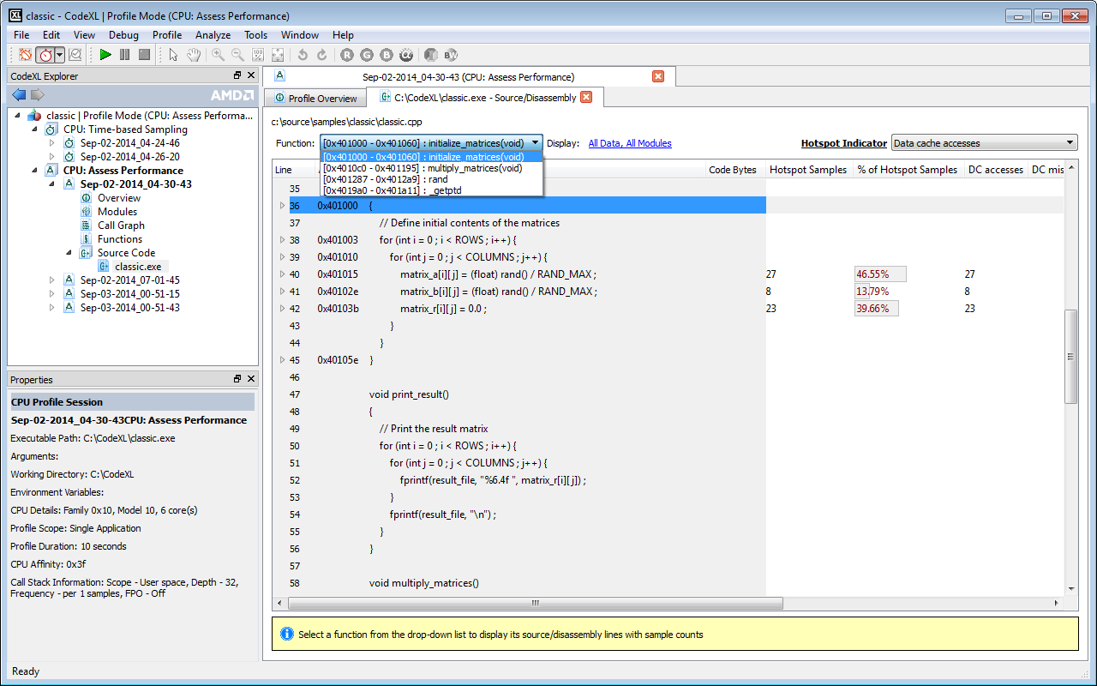

### Analysis with Instruction Based Sampling (IBS)

**Instruction Based Sampling (IBS)** uses the hardware feature called IBS, to collect the IBS Fetch and IBS Op data.

**Collecting IBS profile data**

**Changing the IBS profile collection options**

**Analyzing the IBS profile data**

#### Collecting IBS profile data

To collect the IBS data:

1. **Create a new CodeXL Project**.
2. In the toolbar, select **CPU: Instruction-based Sampling** from the profile configuration list, as shown in the following screenshot.   
   This is a predefined IBS profile configuration provided by CodeXL.

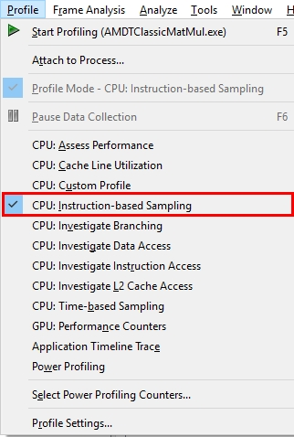

1. Set the profile session options as explained in **Set the CPU Profile Session settings**.
2. Click the Start  icon in the toolbar, or select **Profile > Start Profiling**, as shown below.

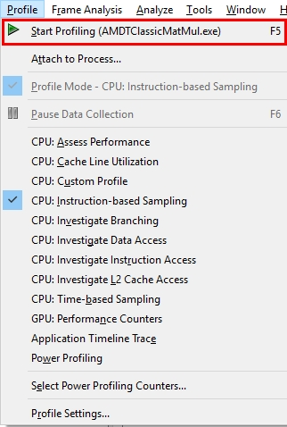

CodeXL begins data collection and launches the specified application program. The start icon is disabled until profiling is in progress. The console window is open, and the launched application is running in the console window. The status bar displays the profile duration while profiling is running; this is the percentage completion of data translation during data translation phase.

#### Changing the IBS profile collection options

CodeXL lets you modify the default profile collection settings. To do this:

1. Set the profile session options as explained in **Set the CPU Profile Session Options**.
2. By default, the sampling interval for TBP is 1 millisecond. To modify the sampling interval, click **Profile > Profile Settings** and click on the **CPU Profile >** **Custom** node in the left pane tree. in the **Edit CodeXL Project Settings** dialog box. The **Custom CPU Profile Monitored Events** page will be displayed.
3. Click the **Interval** field and set the required sampling interval.
4. Click the **OK** button to save the modified profile settings.

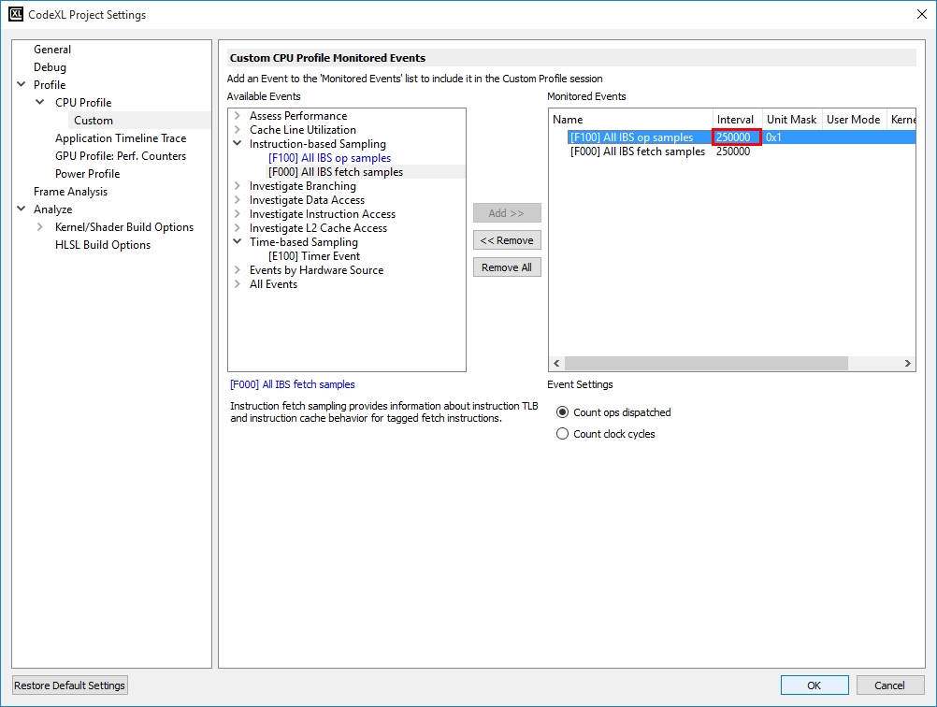

#### Analyzing the IBS profile data

This page explains how to analyze and navigate to the various profile views provided by the CodeXL CPU Profiler. It is comprised of the following modules.

**Overview page**

**Modules view**

**Functions view**

**Call Graph view**

**Source Code view**

##### Overview page

When data collection is complete, CodeXL processes the data and displays the results.

Initially, the **Profile Overview** displays the following profile data.

* **5 Hottest Functions** table
* **5 Hottest Modules** table
* **Execution** section
* **Profile Details** section

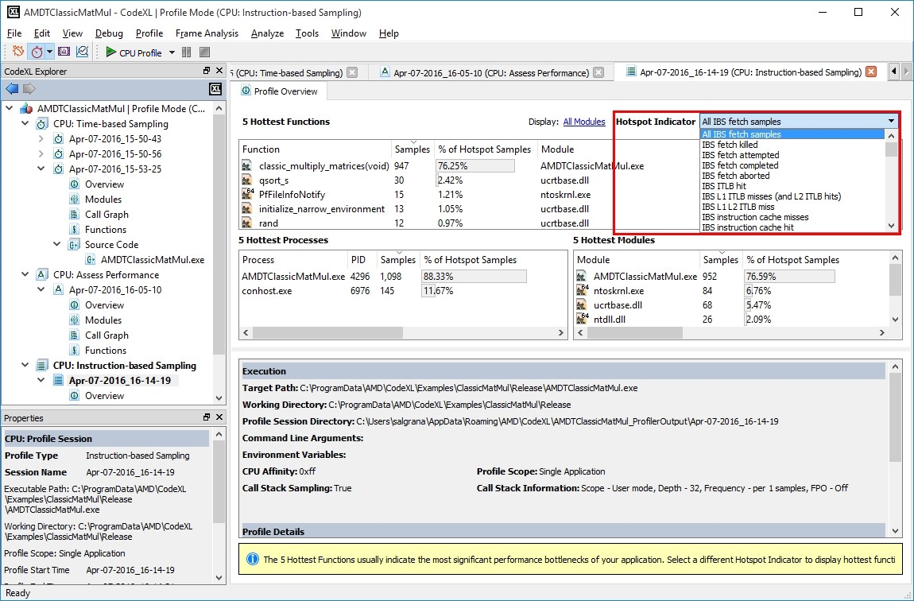

From the overview page you can navigate to various pages to analyze the profile data.

##### Modules view

1. To navigate to Modules view, do one of the following.

* In the CodeXL Explorer pane, double-click on the **Modules** node in the profile session tree entry created for this profile run.   
  The **Modules** view is displayed.
* In the **Overview** page, right-click on the **5 Hottest Modules** table entry, and select **Display in Modules View**.   
  The **Modules** view is displayed.

1. Click on the **Display: All Data, All Modules** link to set the Display Settings.   
   The **Display Settings** dialog box is displayed to let you set the various display settings.

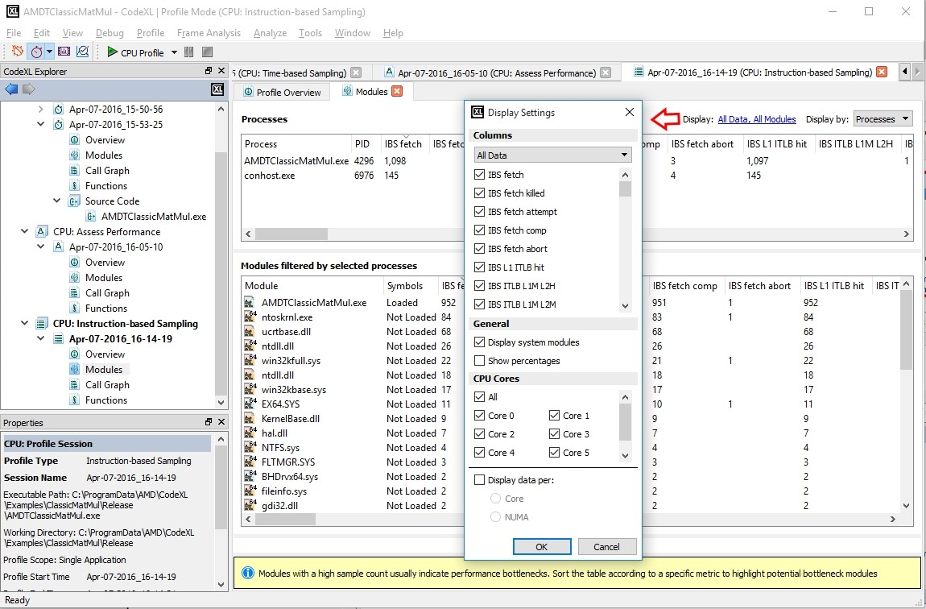

1. Click the **OK** button to save the Display filter settings.

##### Functions view

1. To navigate to Functions view, do one of the following.

* In CodeXL Explorer pane, double-click on **Functions** node in the profile session tree entry created for this profile run.   
  The **Functions** view is displayed with function entries from all the profiled processes and the load modules.
* In the **Overview** page, right-click on the **5 Hottest Modules** table entry, and select **Display in Functions View**.   
  The **Functions** view is displayed with function entries from the selected load module.
* In the **Overview** page, right-click on the **5 Hottest Functions** table entry, and select **Display in Functions View**.   
  The **Functions** view is displayed with function entries from all the profiled processes and the load modules.
* In the **Modules** view, select a Process from the **Processes** table, and select **Display in Functions View**.   
  This displays the functions from the selected process and all its load modules.
* In the **Modules** view, select a Module from the **Modules filtered by selected processes** table, and select **Display in Functions View**.   
  This displays the functions from the selected load module.

1. Click on the **Display: All Data, All Modules** link to set the display settings.   
   The **Display Settings** dialog box is displayed to let you set the various display settings.
2. Click the **OK** button to save the Display filter settings.
3. Click on the **modules shown, modules hidden** link to set the module filter settings to be used in the Functions view.   
   The **CodeXL Modules Filter** dialog box is displayed to let you set the module filter settings.

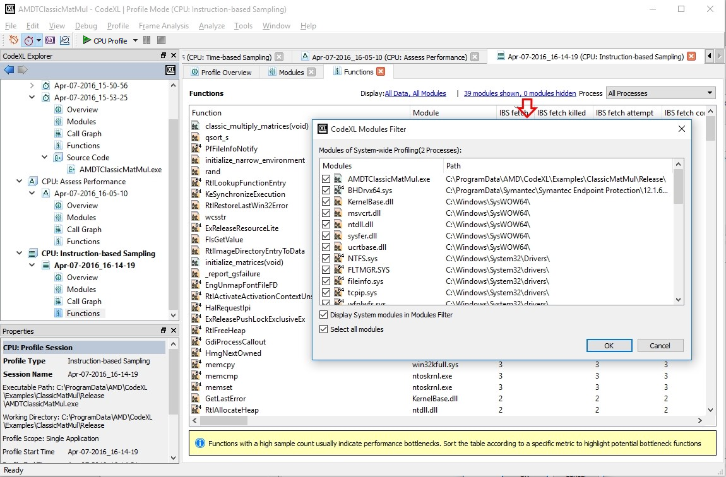

1. Click the **OK** button to save the Modules filter settings.

##### Call Graph view

1. To navigate to Call Graph view, do one of the following.

* In the CodeXL Explorer pane, double-click on the **Call Graph** node in the profile session tree entry created for this profile run.   
  The **Call Graph** view is displayed with Callstack samples collected for the profiled application.
* In the **Overview** page, right-click on the **5 Hottest Functions** table entry, and select **Display in Call Graph View**.   
  The **Functions** view is displayed with Callstack samples collected for the profiled application.
* In the **Functions** view, select a function from the **Functions** table, and select **Display in Call Graph View**   
  This displays the Call Graph constructed from the callstack samples collected from the profiled application.

1. Click on the **Display: All Modules** link to enable the **Display system modules**.   
   This displays the callstack samples collected from the system modules.
2. Click the **OK** button to save the Display filter settings.
3. Click on the **Process** combo box to select the process for which you want to view the Call Graph.

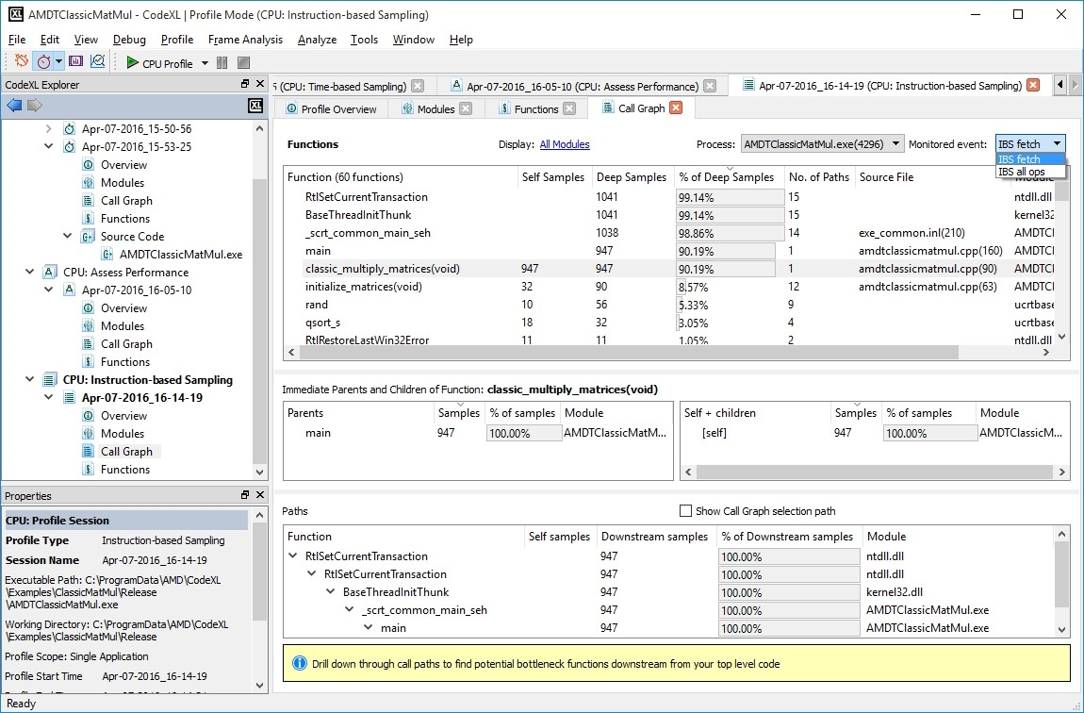

##### Source Code view

1. To navigate to Call Graph view, do one of the following.

* In the **Overview** page, right-click on the **5 Hottest Functions** table entry, and select **Open Source Code**.   
  This displays the **Source Code** view for the selected function.
* In the **Functions** view, select a function from the **Functions** table, right-click and select **Open Source Code** from the context menu.   
  This displays the **Source Code** view for the selected function.
* In the **Call Graph** view, select a function from the **Functions** table, right-click and select **Open Source Code** from the context menu.   
  This displays the **Source Code** view for the selected function.

1. To view the sources for the some other function, click on the **Function** combo-box, and select the function for which you want to view the source code.

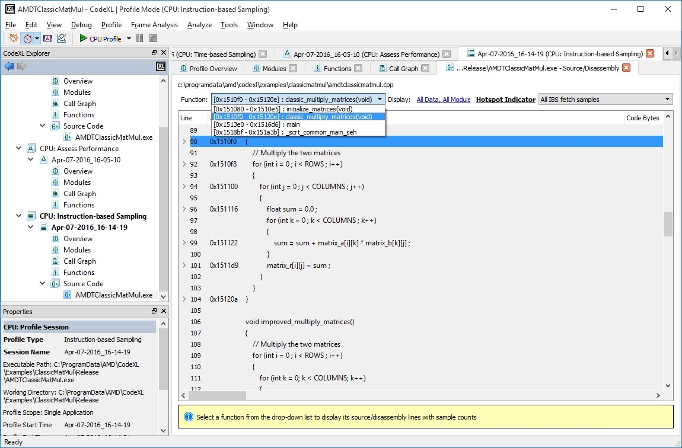

### Analysis with Cache Line Utilization (CLU)

**Cache Line Utilization (CLU)** uses the Load and Store Instruction-Based Sampling (IBS) records to provide a measure of how efficiently an application utilizes the L1 data cache.

**Collecting CLU profile data**

**Changing the CLU profile collection options**

**Analyzing the CLU profile data**

#### Collecting CLU profile data

To collect the CLU data, perform the following steps:

1. First **Create a new CodeXL Project**
2. In the toolbar, select **CPU: Cache Line Utilization** from the profile configuration list, as shown in the following figure. This is a predefined Cache Line Utilization profile configuration provided by CodeXL.

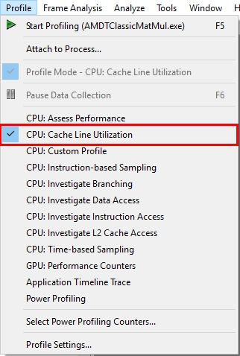

1. Set the profile session options as explained in **Set the CPU Profile Session settings**
2. Click the Start  icon in the toolbar or select **Profile > Start Profiling** as shown below.

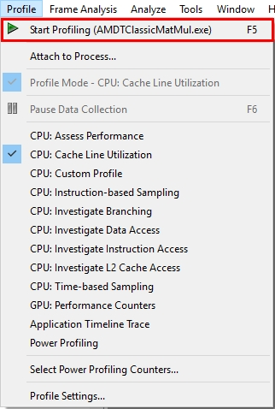

#### Changing the CLU profile collection options

CodeXL lets you modify the default profile collection settings. To do this:

1. Set the profile session options as explained in **Set the CPU Profile Session settings**.
2. By default, the sampling interval for TBP is 1 millisecond. To modify the sampling interval, click **Profile > Profile Settings** and click on the **CPU Profile >** **Custom** node in the left pane tree. in the **Edit CodeXL Project Settings** dialog box. The **Custom CPU Profile Monitored Events** page will be displayed.
3. Click the **Interval** field and set the required sampling interval.
4. Click the **OK** button to save the modified profile settings.

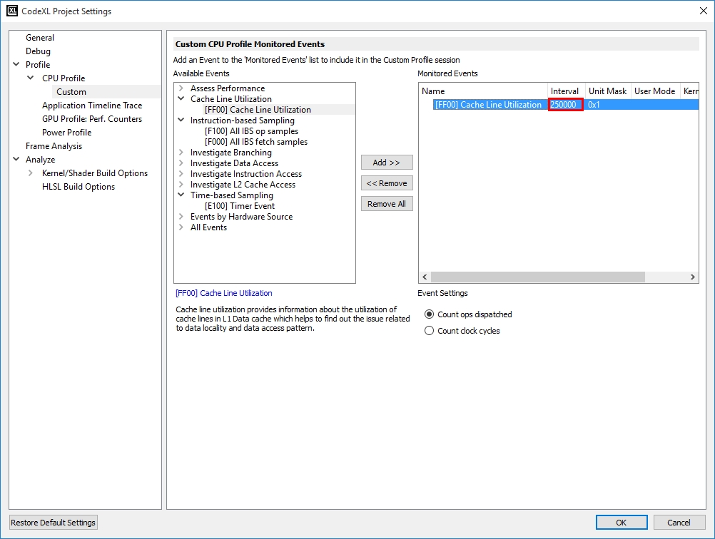

#### Analyzing the CLU profile data

This page explains how to analyze and navigate to the various profile views provided by the CodeXL CPU Profiler.

**Overview page** Overview page

**Modules view** Modules view

**Functions view** Functions view

**Source Code view** Source Code view

##### Overview page

When data collection is complete, CodeXL processes the raw profile data and displays the results.

Initially the **Profile Overview** is displayed. It displays the following profile data:

* **5 Hottest Functions** table
* **5 Hottest Modules** table
* **5 Hottest Processes** table
* **Execution** section
* **Profile Details** section

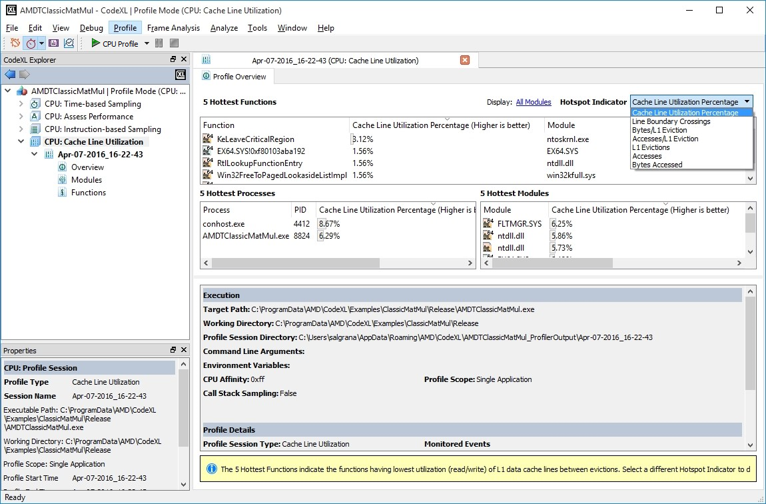

From the overview page the user can navigate to various pages to analyze the profile data.

##### Modules view

1. To navigate to Modules view, do any of the following:

* In CodeXL Explorer pane, double click on **Modules** node in the profile session tree entry created for this profile run. The **Modules** view is displayed.
* In **Overview** page, right click on **5 Hottest Modules** table entry and select **Display in Modules View**. The **Modules** view is displayed.

1. Click on **Display: All Data, All Modules** link to set the Display Settings. The **Display Settings** dialog box is displayed to enable the users to set the various display settings.

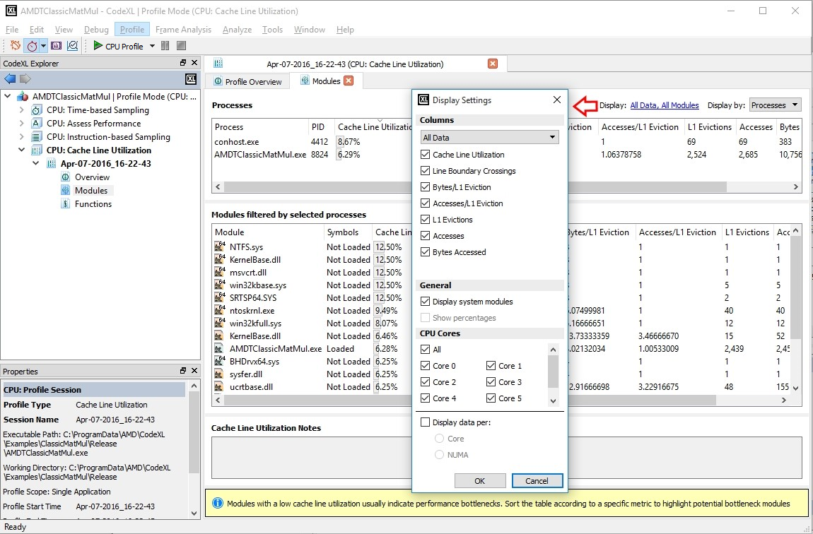

##### Functions view

1. To navigate to Functions view, do any of the following:

* In CodeXL Explorer pane, double click on **Functions** node in the profile session tree entry created for this profile run. The **Functions** view is displayed with function entries from all the profiled processes and the load modules.
* In **Overview** page, right click on **5 Hottest Modules** table entry and select **Display in Functions View**. The **Functions** view is displayed with function entries from the selected load module.
* In **Overview** page, right click on **5 Hottest Functions** table entry and select **Display in Functions View**. The **Functions** view is displayed with function entries from all the profiled processes and the load modules.
* In **Modules** view, select a Process from the **Processes** table, and select **Display in Functions View**. This displays the functions from the selected process and all its load modules.
* In **Modules** view, select a Module from the **Modules filtered by selected processes** table, and select **Display in Functions View**. This displays the functions from the selected load module.

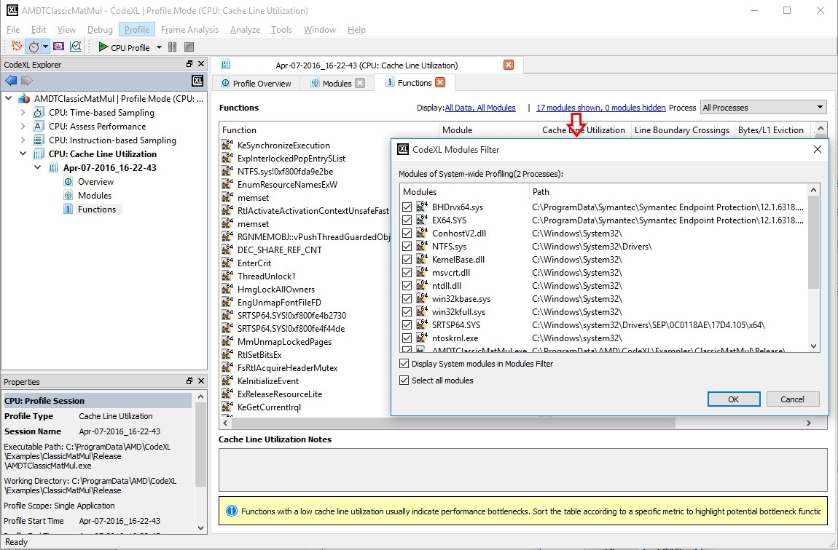

##### Source Code view

1. To navigate to Source view, do any of the following:

* In **Overview** page, right click on **5 Hottest Functions** table entry and select **Open Source Code**. This displays the **Source Code** view for the selected function.
* In **Functions** view, select a function from the **Functions** table, right click and select **Open Source Code** from the context menu. This displays the **Source Code** view for the selected function.

1. To view the sources for the some other function, click on the **Function** combo box and select the function for which you want to view the source code.

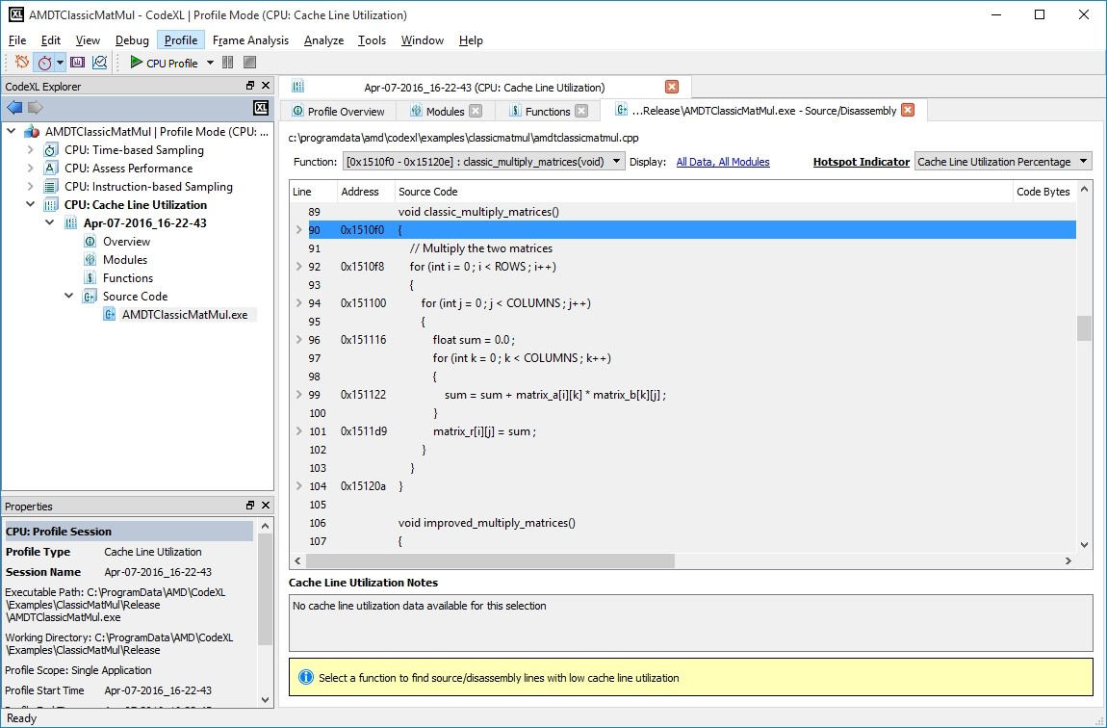

### Settings for C++ Inline Functions

#### Microsoft Visual Studio

Prior to Visual Studio 2013 Update 3, inline function information was not preserved in the PDB file. For CodeXL, to extract inline information from PDB file, the target application must be compiled with Visual Studio 2013 Update 3 or later. Use the below Visual Studio Configuration Properties if you want to enable inline function details in CodeXL CPU Profiler.

* Set **Configuration Properties > C/C++ > General > Debug Information Format** to **/Zi**. Without this flag, PDB file with debug info will not be generated.

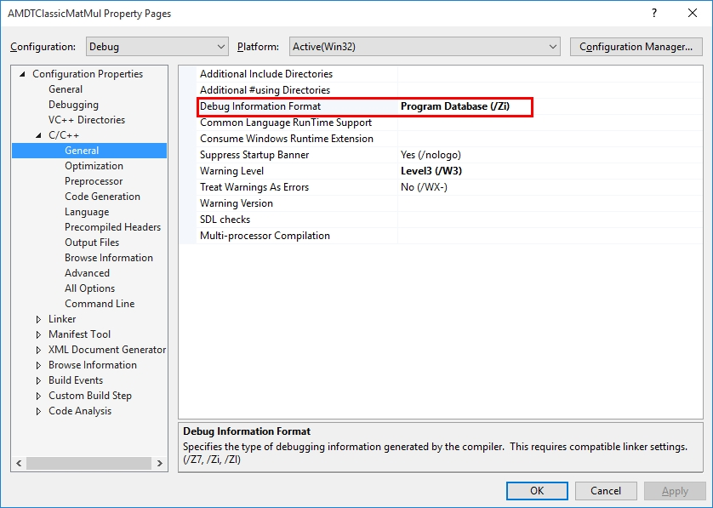

* Add **/Zo** to **Configuration Properties > C/C++ > Command Line > Additional Options**. Without this flag, additional debug info related to inline functions will not be generated. /Zo only recognized by VS2013 update 3 or later. The **/Zo** option is enabled by default in Visual Studio 2015 when you specify debugging information with **/Zi** or **/Z7**, hence this step is optional for VS2015.

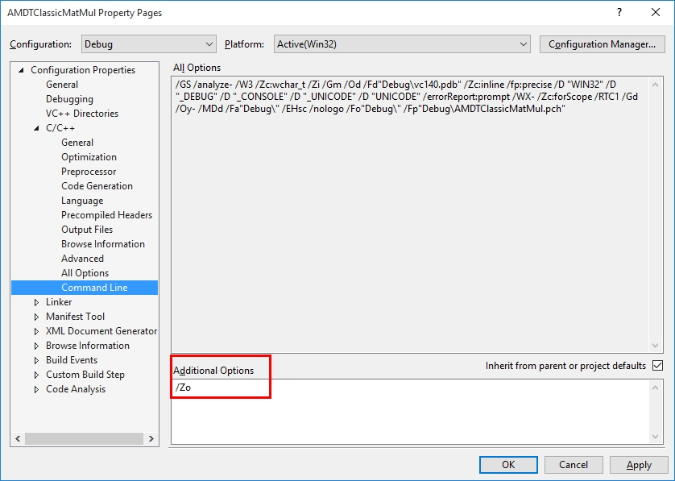

* Enable Optimization by setting any one of: /O1, /O2, /Ox (**Configuration Properties > C/C++ > Optimization > Optimization**). Setting it to /Od will stop all optimizations including function inline.
* Enable Function inlining by setting one of: /Ob1, /Ob2 (**Configuration Properties > C/C++ > Optimization > Inline Function Expansion**). Setting it to /Ob0 will stop function inline.

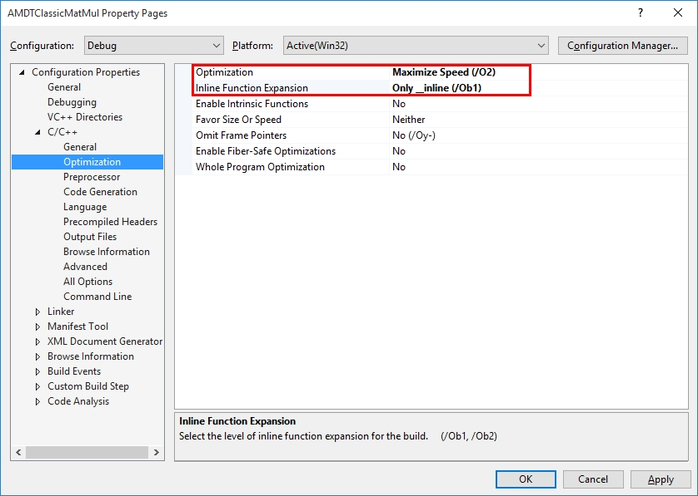

* On Visual Studio 2015, enable “Whole Program Optimization” (**Configuration Properties > C/C++ > Optimization > Whole Program Optimization**). This setting is not required for VS2013.

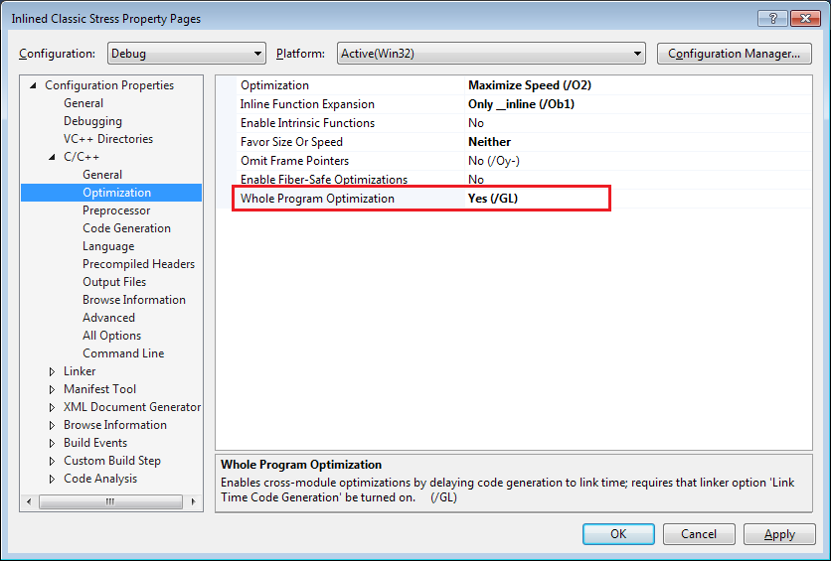

* Disable data elimination by setting /OPT:NOREF (**Configuration Properties > Linker > Optimization > References**). Setting it to /OPT:REF eliminates unreferenced data/function during linking time. In Release build, by default REF is enabled, due to which inline function info gets removed from PDB file.
* Disable COMDAT folding by setting /OPT:NOICF (**Configuration Properties > Linker > Optimization > Enable COMDAT Folding**). Setting it to /OPT:ICF combines identical functions. In Release build, by default ICF is enabled, due to which identical inline functions info gets removed from PDB file.

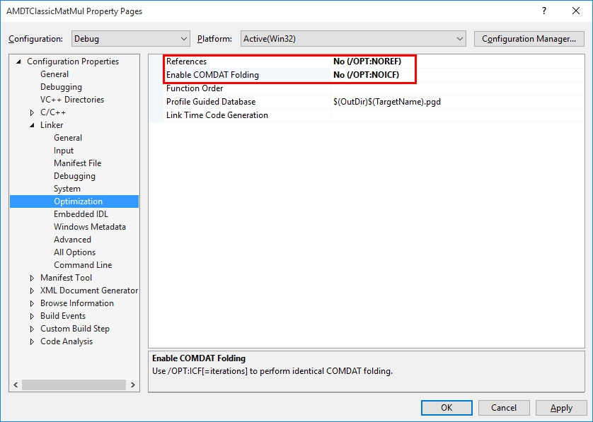

#### GCC/G++ Compiler

* Enable debug info using “-g” or “-gdwarf-*version*”. Without this option, target application binary will not include any debugging information.
* Enable optimization using any one of: -O, -O1, -O2, or -O3. Without this option, compiler will disable any function inlining.

#### Session Views

Following screenshots for Overview, Call Graph view and Source Code view shows the inline functions for a sample target application.

##### Overview page

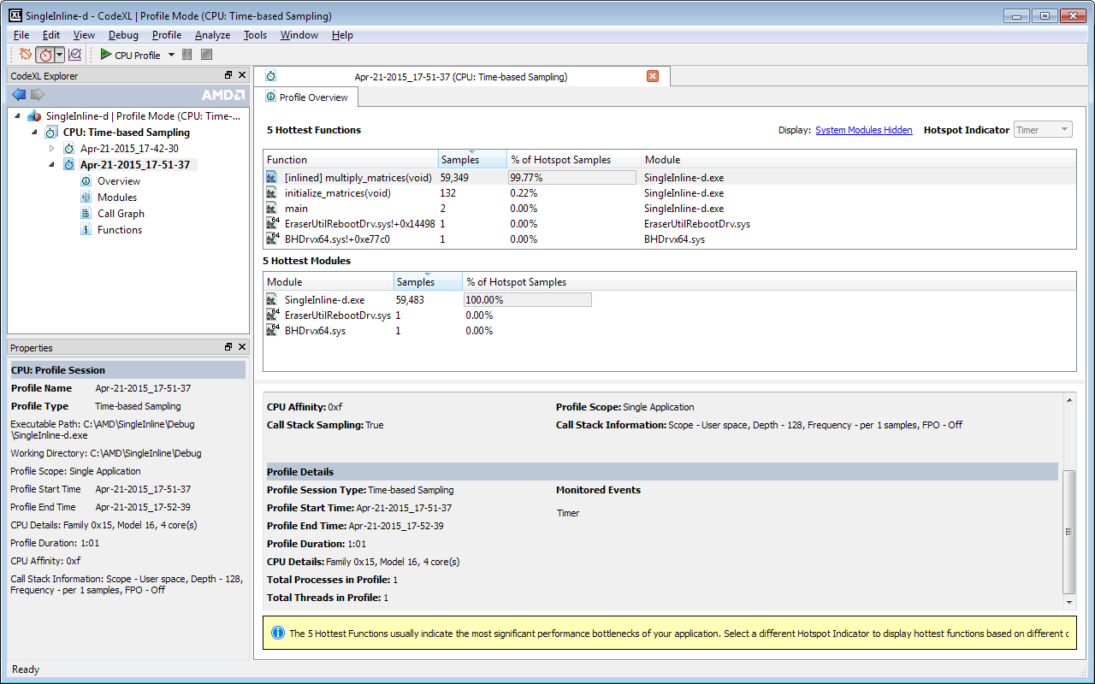

Inline function “multiply_matrices(void)” is shown in the 5 Hottest Functions table.

##### Call Graph View

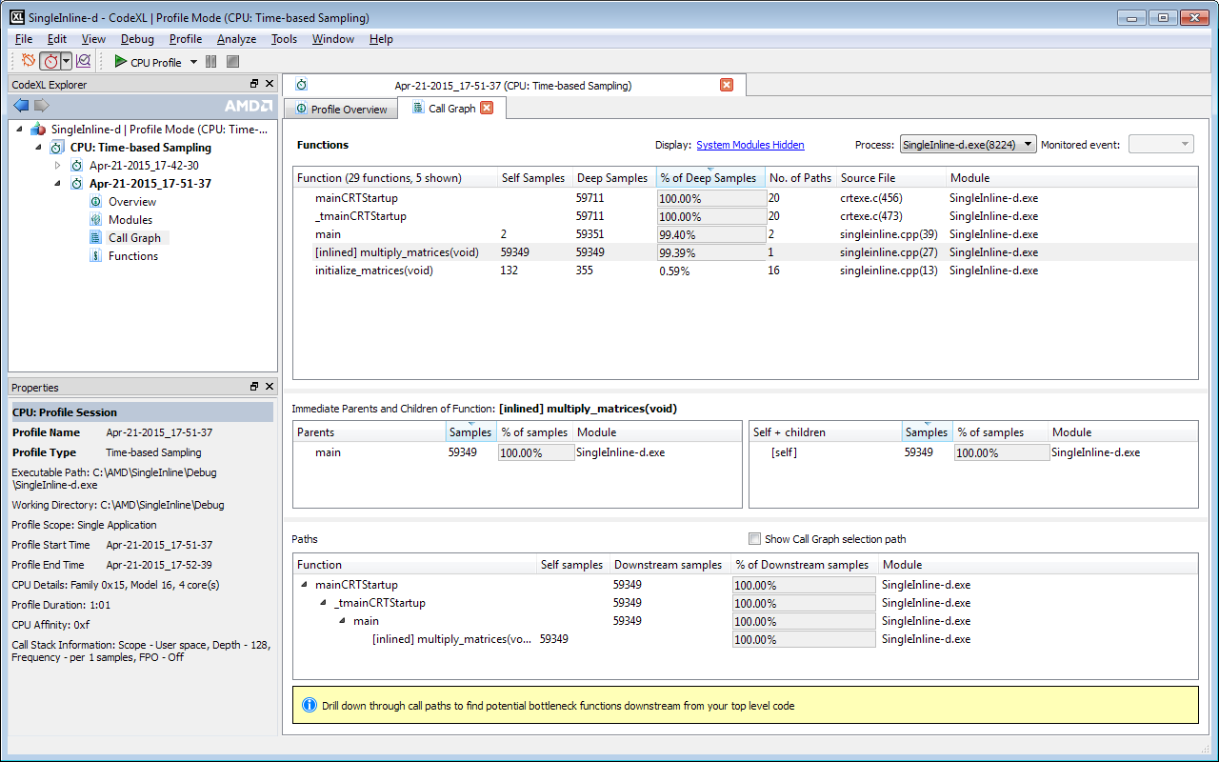

Inline function “multiply_matrices(void)” is shown in the Functions table and Paths table.

##### Source Code View

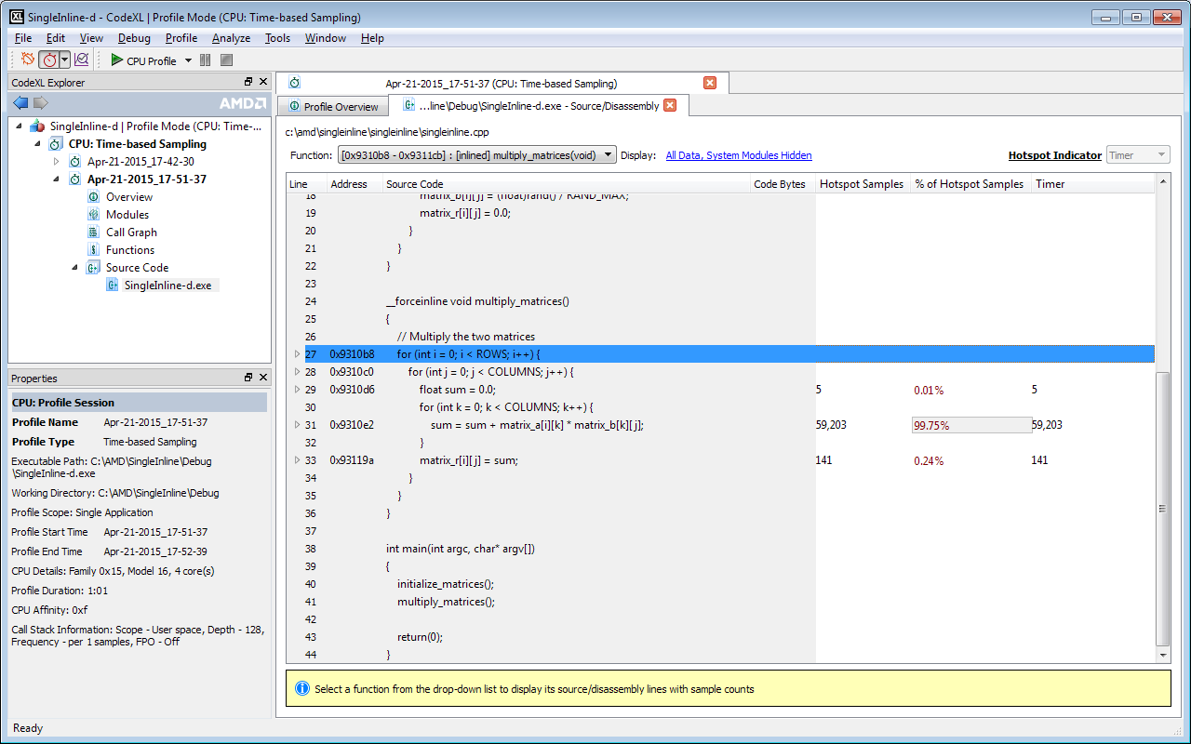  
Samples are attributed to corresponding source lines for Inline function “multiply_matrices(void)”.

### Settings for CPU Profiler to run on Virtual Machine

CPU Profiler supports profiling on guest OS running on VMware workstation.

#### VMware Workstation

CPU Profiler supports TBP and EBP on guest OS running on VMware Workstation 11.0 or later. Recent AMD Carrizo processor is not yet supported by VMware Workstation 11.1.x.

To run TBP within guest OS, no additional configuration needed in host OS or guest OS.

To run EBP within guest OS, please ensure the following settings are done:

* Enable Virtualization or SVM (AMD-V) in BIOS settings before booting the host OS.
* Enable AMD-V in guest OS VM settings. Edit virtual machine settings > Hardware > Processors> Virtualization engine > Enable “Virtualize AMD-V/RVI”
* Enable vPMC in guest OS VM settings. Edit virtual machine settings > Hardware > Processors> Virtualization engine > Enable “Virtualize CPU performance counters”

**Known Issues on Windows 7 Host OS:**

* When CPU Profiler EBP is running on Windows 7 host OS and a Linux guest OS is launched, crash is observed on Windows 7 due to VMware driver.
* If EBP is performed on Windows 7 host OS and EBP is performed on Linux guest OS simultaneously, then crash is observed on Windows 7 due to VMware driver.

These scenarios work fine when host OS is Windows 8, 8.1 and 10.

### How to use CPU Profiler Control APIs

CPU Profile control APIs provide the option to restrict the profiling to a specific part of the code. Follow the below steps to call, compile and invoke these APIs from your target program.

#### Required File Paths

All the paths mentioned below are with respect to CodeXL installation directory (CODEXL-INSTALL-DIR).

API Documentation:

<CODEXL-INSTALL-DIR>\SDK\AMDTActivityLogger\doc\AMDTActivityLogger.pdf (on Windows platforms)

OR

<CODEXL-INSTALL-DIR>/SDK/AMDTActivityLogger/doc/AMDTActivityLogger.pdf (on Linux platforms)

Header File:

<CODEXL-INSTALL-DIR>\SDK\AMDTActivityLogger\include\AMDTActivityLogger.h (on Windows platforms)

OR

<CODEXL-INSTALL-DIR>/SDK/AMDTActivityLogger/include/AMDTActivityLogger.h (on Linux platforms)

LIB Files (on Windows platforms):

<CODEXL-INSTALL-DIR>\SDK\AMDTActivityLogger\lib\x64\AMDTActivityLogger-x64.lib

<CODEXL-INSTALL-DIR>\SDK\AMDTActivityLogger\lib\x86\AMDTActivityLogger.lib

DLL Files (on Windows platforms):

<CODEXL-INSTALL-DIR>\SDK\AMDTActivityLogger\bin\x64\AMDTActivityLogger-x64.dll

<CODEXL-INSTALL-DIR>\SDK\AMDTActivityLogger\bin\x86\AMDTActivityLogger.dll

Shared Library (.so) Files (on Linux platforms):

<CODEXL-INSTALL-DIR>/SDK/AMDTActivityLogger/bin/x86_64/libAMDTActivityLogger.so

<CODEXL-INSTALL-DIR>/SDK/AMDTActivityLogger/bin/x86/libAMDTActivityLogger.so

#### Calling the APIs

Include the header file AMDTActivityLogger.h, and call the resume and pause APIs within the code. The code encapsulated within resume-pause API pair will be profiled by CPU Profiler.

These APIs can be called multiple times to profile different parts of the code.

These APIs can be spread across multiple functions, i.e. resume called from one function and stop called from another function.

These APIs can be spread across threads, i.e. resume called from one thread and stop called from another thread of the same target application.

In the below example, the CPU Profiler is restricted to the execution of multiply_matrices() function.

#include <AMDTActivityLogger.h>

int *main*(int **argc**, char* **argv**[])

{

    // Initialize the matrices

*printf*("Initializing matrices\n");

    initialize_matrices();

    // Multiply the matrices

*printf*("Multiplying matrices\n");

// Resume the CPU profiler

// amdtResumeProfiling(AMDT_CPU_PROFILING);

*amdtResumeProfilingEx*();

    multiply_matrices();

// Stop the CPU Profiler

// amdtStopProfiling(AMDT_CPU_PROFILING);

*amdtStopProfilingEx*();

    return 0;

}

#### Compiling the target application

To compile the application on Microsoft Visual Studio, update the configuration properties to include the path of header file, DLL file, LIB file of AMDTActivityLogger.

To compile a C++ application on Linux using G++, use the following command:

$ g++ -std=c++0x <source-file.cpp> -L<CODEXL-INSTALL-DIR>/SDK/AMDTActivityLogger/bin/x86_64/ -L<CODEXL-INSTALL-DIR> -I<CODEXL-INSTALL-DIR>/SDK/AMDTActivityLogger/include -lAMDTBaseTools -lAMDTOSWrappers -lAMDTActivityLogger -lrt –ldl

You may choose to use 2011 C++ standard or newer C++ standard while compiling C++ target application with profile control APIs.

To compile a C application on Linux using GCC, use the following command:

$ gcc <source-file.c> -L<CODEXL-INSTALL-DIR>/SDK/AMDTActivityLogger/bin/x86_64/ -L<CODEXL-INSTALL-DIR> -I<CODEXL-INSTALL-DIR>/SDK/AMDTActivityLogger/include -lAMDTBaseTools -lAMDTOSWrappers -lAMDTActivityLogger -lrt

#### Profiling with Control APIs

After the compiling the target application, create a project in CodeXL, set the general profile session options, set the CPU profile session options. While setting the CPU profile session options, in step 4, in the **Data Collection Schedule** section, select **Start profile with data collection paused**.

Once all the settings done, start the CPU profiling. The CPU Profiler will be in pause state and target application execution begins. When the resume API gets called from target application, CPU Profile starts profiling till stop API gets called from target application. As soon as stop API is called in target application, CPU Profiler stops profiling and waits for next control API call.

To profile from CLI, option ‘-s 0’ should be used to start the profiler in pause state.

Sample command on Windows platforms:

> CodeXLCpuProfiler.exe collect -m tbp **-s 0** -o c:\Temp\cpuprof-tbp <target-application.exe>

Sample command on Linux platforms:

$ CodeXLCpuProfiler collect -m tbp **-s 0** -o /tmp/cpuprof-tbp <target-application>